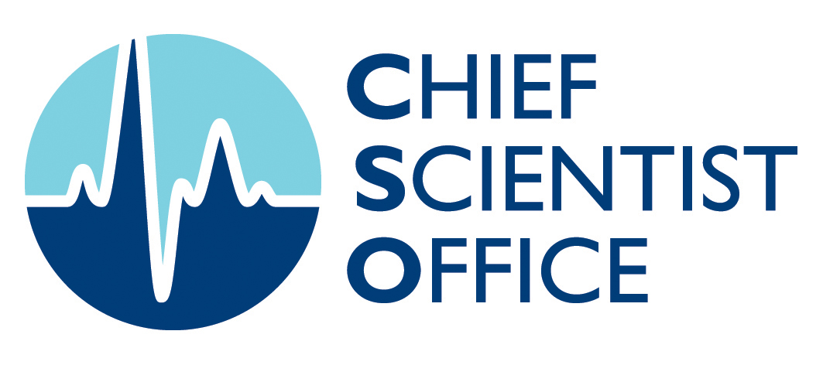
Researchers
Chief Scientist Office, St Andrews House, Regent Road, Edinburgh, EH1 3DG Tel:0131 244 2248
www.cso.scot.nhs.uk
Scottish Government Health Directorates Chief Scientist Office
FOCUS ON RESEARCH
Identifying novel targets for eradication of acute lymphoblastic leukaemia in the central nervous system

Dr Christina Halsey & Dr Pawel Herzyk, Institute of Cancer Sciences, University of Glasgow, and Prof Eyal Gottlieb, Beatson Institute for Cancer Research Glasgow.

Aim
Acute lymphoblastic leukaemia is the commonest childhood cancer. Great treatment advances mean that more than 90% of children now survive, although many suffer significant side effects. One particularly challenging area is how best to treat leukaemia that has spread from the bone marrow (where it originates) to the brain (known as the central nervous system, CNS). All children receive large amounts of CNS-targeted chemotherapy to try to prevent recurrence of leukaemia in the brain. This treatment is unpleasant and can have serious side effects including seizures and reduced IQ.
The aim of this project was to identify new ways of treating CNS leukaemia – gentler therapies and better predictive tests, for children at low and high risk of CNS recurrence, are urgently needed.

Project Outline/Methodology
This study used a combination of animal models of CNS leukaemia and samples from children undergoing treatment for leukaemia to investigate:
1. Differences between leukaemic cells isolated from the bone marrow and CNS in order identify how leukaemia cells adapt to the new environment in the CNS and whether blocking these adaptations may be a more effective and specific treatment.
2. New tests that might be able to pick up sub-microscopic levels of leukaemia and predict recurrence by measuring small molecules in the fluid around the brain where the leukaemia cells live – the cerebrospinal fluid (CSF).
We used a combination of cutting-edge techniques to look at expression of all genes in cells from the two sites (RNA-sequencing) and the chemical adaptations within the cells to new environments (metabolomics).

Key Results
We were able to identify some key differences between cells in the CNS and bone marrow. In particular, we saw that cells in the CNS appeared to be “starved” of fats and cholesterol. We know that fats and cholesterol are needed to make new cell membranes and to provide an energy store for the cell. Normal blood is rich in these nutrients but we found that CSF has levels more than 100 times lower than blood. Therefore, trying to block the production of fats and cholesterol in leukaemia cells may cause the cells to die. We tested this by using drugs that block an important step in making unsaturated fats. This treatment resulted in a reduction in CNS leukaemia compared to the bone marrow.
In addition, we compared CSF from children with and without leukaemia and found some important differences in the levels of small molecules involved in metabolism (the chemical processes that occur within living organisms to maintain life). We are now testing whether measuring levels of these molecules will allow us to track how well CNS leukaemia is responding to treatment.

Conclusions
We have identified a number of critical metabolic pathways that sustain leukaemic cells within the CNS and have shown that targeting one of these pathways (fatty acid biosynthesis) can lead to a reduction in CNS leukaemia.

What does this study add to the field?
We have identified fatty acid and cholesterol synthesis as important areas for drug development to eradicate CNS leukaemia. In addition, we have discovered new diagnostic tests for CNS leukaemia. Better tracking of the response of CNS leukaemia to treatment will allow us to develop personalised treatment for children tailored to their individual risk of CNS recurrence

Implications for Practice or Policy
We hope to test our diagnostic tests further, once we have confirmed that they are accurate and specific for CNS leukaemia we will test how well they predict CNS leukaemia recurrence in a large multicentre trial.

Where to next?
We have applied for more funding to continue this work on diagnostic tests and new therapies.

Further details from:
Dr Christina Halsey, Institute of Cancer Sciences, University of Glasgow, chris.halsey@glasgow.ac.uk

