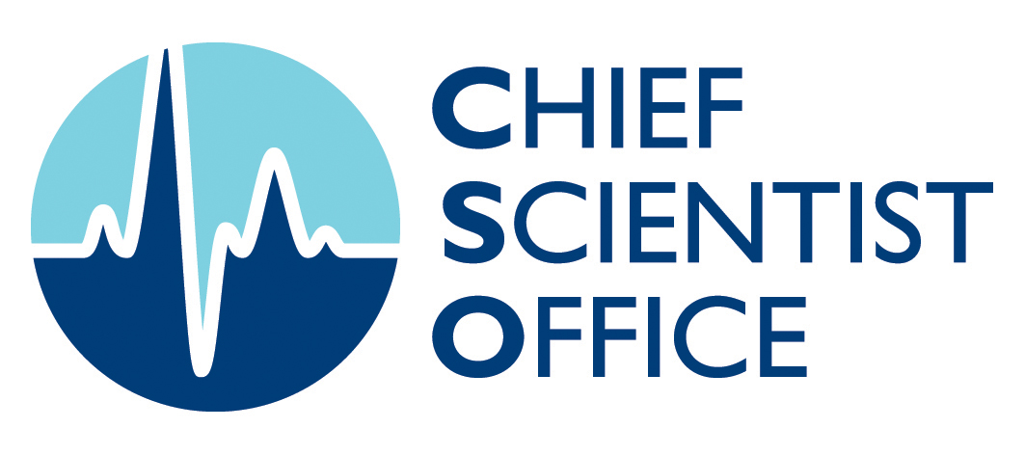
Researchers
Chief Scientist Office, St Andrews House, Regent Road, Edinburgh, EH1 3DG Tel:0131 244 2248
www.cso.scot.nhs.uk
Scottish Government Health Directorates Chief Scientist Office
FOCUS ON RESEARCH
Can an arts based creative engagement intervention following stroke improve psychosocial outcomes? A feasibility trial of a creative engagement intervention for in-patient rehabilitation.

PI: Dr Jacqui Morris; Co-applicants: Chris Kelly, Dr Sara Joice, Prof Thilo Kroll, Prof Peter Donnan, Prof Brian Williams, Prof Gillian Mead. Researchers: Dr Madalina Toma, Dr Alex Johns
Aims - To:
- Model a creative engagement intervention (CEI) and identify potential outcomes
- Examine feasibility of a randomised controlled trial (RCT) and assess potential benefits
- Examine how initial preference for art participation influences recruitment, retention and outcomes
- Examine trial participation experiences
Project Outline/Methodology
Phase 1: Intervention modelling and outcome identification: interviews with artists (n=3) and previous participants of Tayside CEI (n=11) and two focus groups with heathcare professionals (n=8).
Phase 2: Two-armed, single blinded feasibility RCT in two rehabilitation units. Stroke survivors were randomised to CEI group (n=41) or usual care control group (n=40). Outcomes were assessed at baseline (T1), end of intervention (T2) and three month follow-up (T3).
Phase 3: Post-intervention interviews with stroke survivors (n=12) artists (n=2) and two focus groups with health professionals (n=11).
Key Results
Phase 1 Participants valued the CEI for perceived effects on mood, physical and communication recovery and self-esteem. Art particpation provided confidence for success in art and other activities (self-efficacy). Control of recovery and hope were also perceived to improve. The findings informed an explanatory model of the intervention.
Phase 2 The RCT was feasible, but randomisation timing meant group sessions were not always possible. Recruitment was as anticipated. Initial preference to do art appeared important for retention, with 20% (n=8) CEI group and 5% (n=2) control participants dropping out by T2. Six CEI dropouts had no initial preference or their preference was not met. The Stroke Impact Scale (SIS) was the primary outcome. At T2 mean scores in all outcomes except SIS Social Participation, Positive Affect, and the Self-efficacy for Art scale were higher in the control group, significantly so for self-esteem. However mean change on most outcomes between T1 and T2 was higher in the CEI group. At T3 significantly greater self-efficacy for art in the CEI group and significantly higher general self-efficacy in the control group was found. The CEI group again showed greatest change in emotion and most secondary outcomes between T1 and T3 although differences were small. Change scores suggest those who complete participation may improve most.
Phase 3 indicated the CEI was a positive experience for participants and highlighted changes in trial processes to assist recruitment and retention.
Conclusions
Patients and staff valued the CEI, and conducting a trial of the intervention was feasible. The CEI seems to improve participants’ mood and enhances their social participation. Confidence obtained through success in art making appears important to that process. However other benefits suggested by Phase 1 findings were not realised. The number and characteristics of the survivors who dropped out, and the nature of stroke recovery itself may have influenced findings. Preference for art probably influences intervention retention and should be assessed before randomisation.
What does this study add to the field?
This study provides a new model of how art participation might work to benefit wellbeing after stroke and shows that a trial of this intervention is feasible. The study provides detailed description of an art intervention and new information suggesting the scope of potential benefits of CEI participation.
Implications for Practice or Policy
The study shows art particpation is valued by stroke survivors and healthcare staff and suggests that preference is important to particpation. The study will guide development of new art programmes in practice.
Where to next?
The intervention and outcomes will be refined before seeking funds for a full scale trial of stepped wedge or crossover design. Further details from: Dr Jacqui Morris, Social Dimensions of Health Institute, University of Dundee j.y.morris@dundee.ac.uk

